ORDINANCE NO. 346
An ordinance regulating public offenses with the corporate limits of the City of Gridley Kansas, incorporating by reference the Uniform Public Offense Code for Kansas Cities, 37th edition.
Be it ordained by the governing body of the city of GRIDLEY, KANSAS:
SECTION l. Section 11-101 of the Code of the City of Gridley is hereby amended to read as follows:
11-101 INCORPORATING "UNIFORM PUBLIC OFFENSE CODE" There is hereby incorporated by reference for the purpose of regulating public offenses within the Corporate Limits of the City of Gridley, Kansas, the Uniform Public Offense Code, 38th Edition, prepared and published in book form by the League of Kansas Municipalities, Topeka, Kansas.
Passed by the council the 3-rd. day of August. 2022. APPROVED by the Mayor.
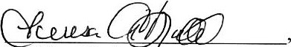
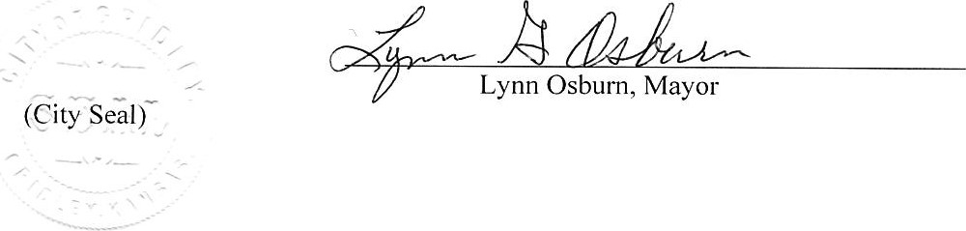ATTEST:
Teresa Budd, City Clerk
APPROVED AS TO FORM: /s/ Rustin J. Kimmell, City Attorney

