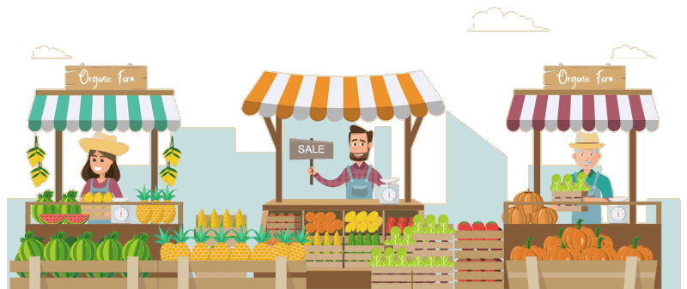
FINAL 2 WEEKS
FARMERS MARKET
GRIDLEY CITY PARK
SATURDAY
AUGUST 26, 2023
SEPTEMBER 2, 2023
7:30 – 9:30am
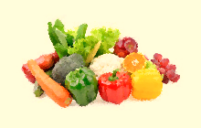
FRESH PRODUCE, BAKED BREAD, CINNAMON ROLLS AND MORE

